STATION 1
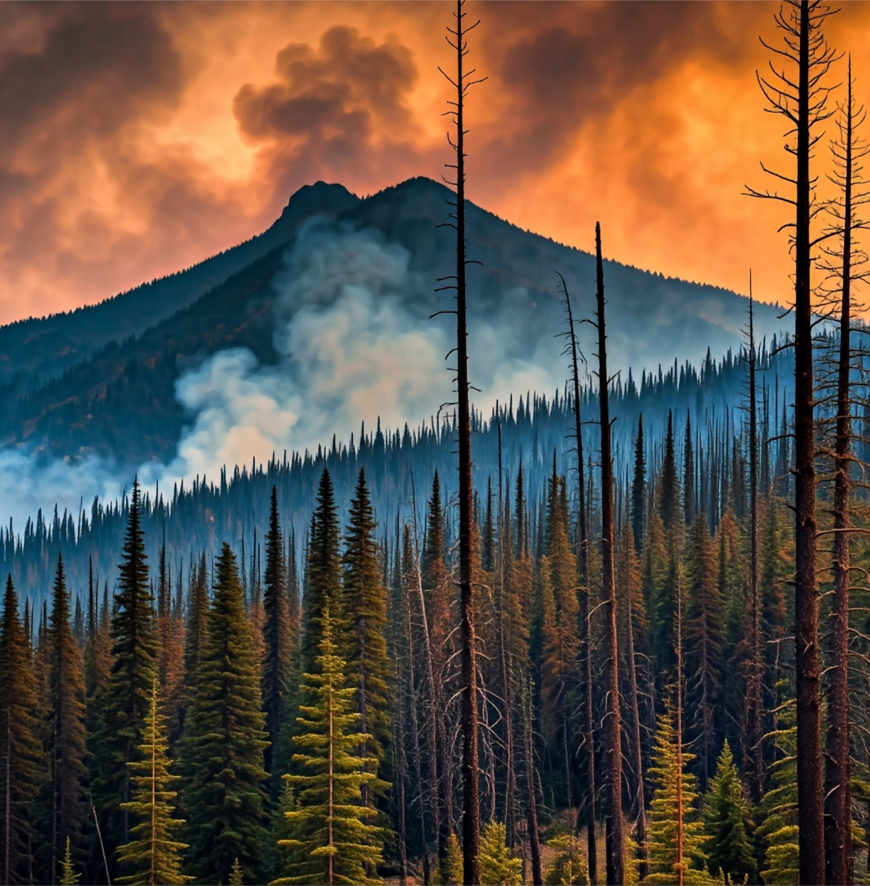
FOREST FIRE RAGING
Station 1 options (according to dice roll)
- You are caught in the flames; make your call 3 times before you die; return to the start & choose a new bird.
- You are confused by the smoke, make your call 3 times, and roll the dice.
- You fly around the flames; flap your “wings” 3 times per step and call; go to Station 2
- Winds help you to fly (walk) quickly to station 2 (1 wing flap per step).
- Breathing the smoke makes you ill; flap your wings 5 times per step; make a sick call with each step; go to Station 2.
- You fly easily around the fire and go to Station 2; make your call to celebrate with a wing flap for each step.
STATION 2


SEVERE DROUGHT
Station 2 options (according to dice roll)
- The drought did not kill your food source. Eat your fill, call 3 times, flap your way to Station 3 (1 flap per step).
- You lucked out and landed in good habitat. Eat, be happy and fly to Station 3 (use 1 wing flap and call per step)!
- Where are the plants? You are exposed to a predator! Call 5 times! Roll the dice again.
- Insects or fruit you eat are gone, so you go back to Station 1 calling with every flap.
- Your food source is scarce, but you make your call 3 times and roll again!
- You are dehydrated and need to drink and bathe! NOPE! Make your call 3 times; return to Station 1.
STATION 3
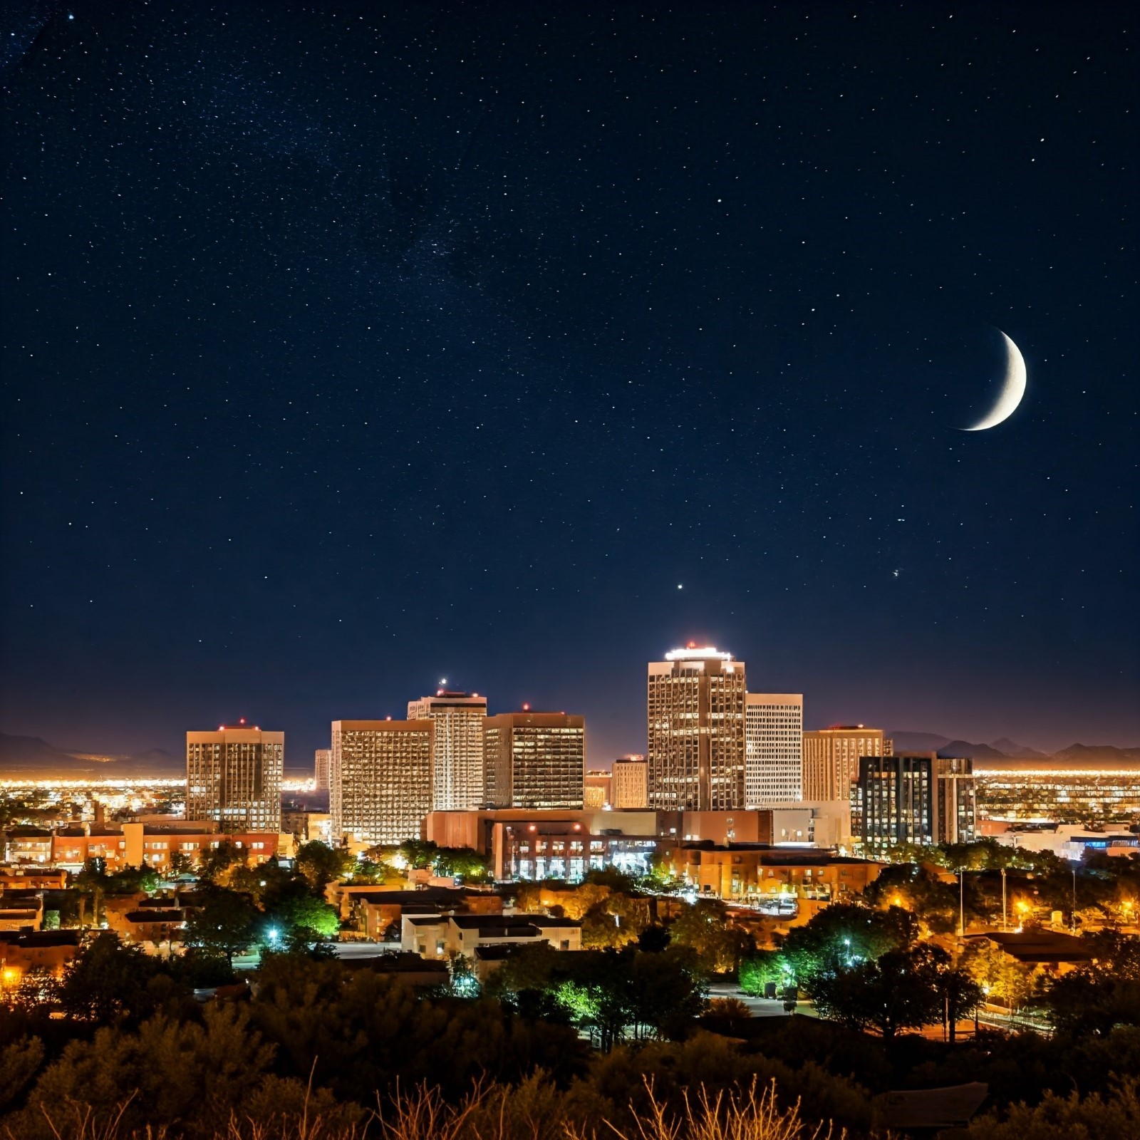
CONFUSING CITY LIGHTS

Station 3 options (according to dice roll)
- Guiding stars are not visible! City lights confuse you! Call and fly 3 big circles around this station. Roll the dice again.
- You fly SMACK into a building! Return to beginning. Get a new bird.
- This city does not have much food and is too hot! Fly in 2 big circles & roll again.
- You land in a yard with native plants, eat your fill and quickly move to Station 4 (1 flap per step).
- You fly into a power line! Flap and call 10 times while you recover. Roll again.
- You find the protection of a flock of backyard Chickadees, eat your fill, and fly to Station 4 (1 flap per step).
STATION 4
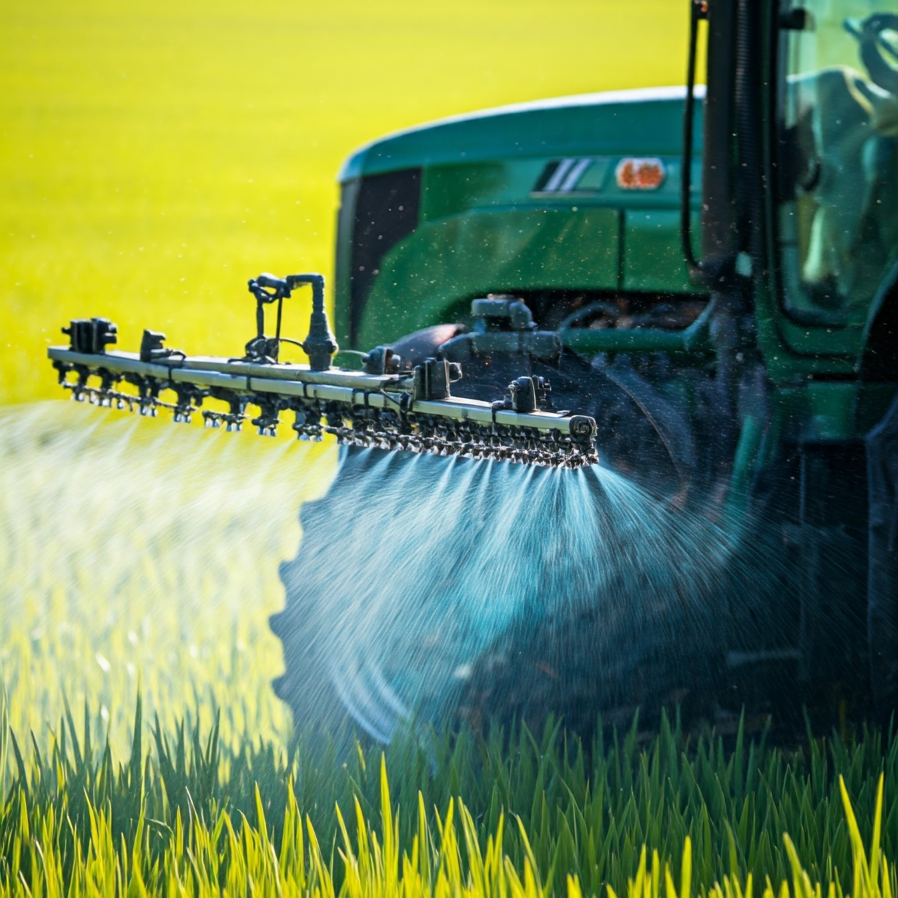
PESTICIDE USE

Station 4 options (according to dice roll)
- You land in a field with no pesticides! You have migrated successfully!
- Pesticides on insects make you ill. Call a sick call and fly 5 big circles around this station. Roll again.
- Pesticides have killed the insects you eat and you are hurting. Go back to Station 3.
- You avoid the pesticide field & eat your fill on a hillside. You migrated successfully!
- You feel confused by the poison and fly the wrong direction. Return to Station 3 calling and flapping.
- You land in a gorgeous backyard with native plants! You have migrated successfully. Congratulations!
STATION 1(B)
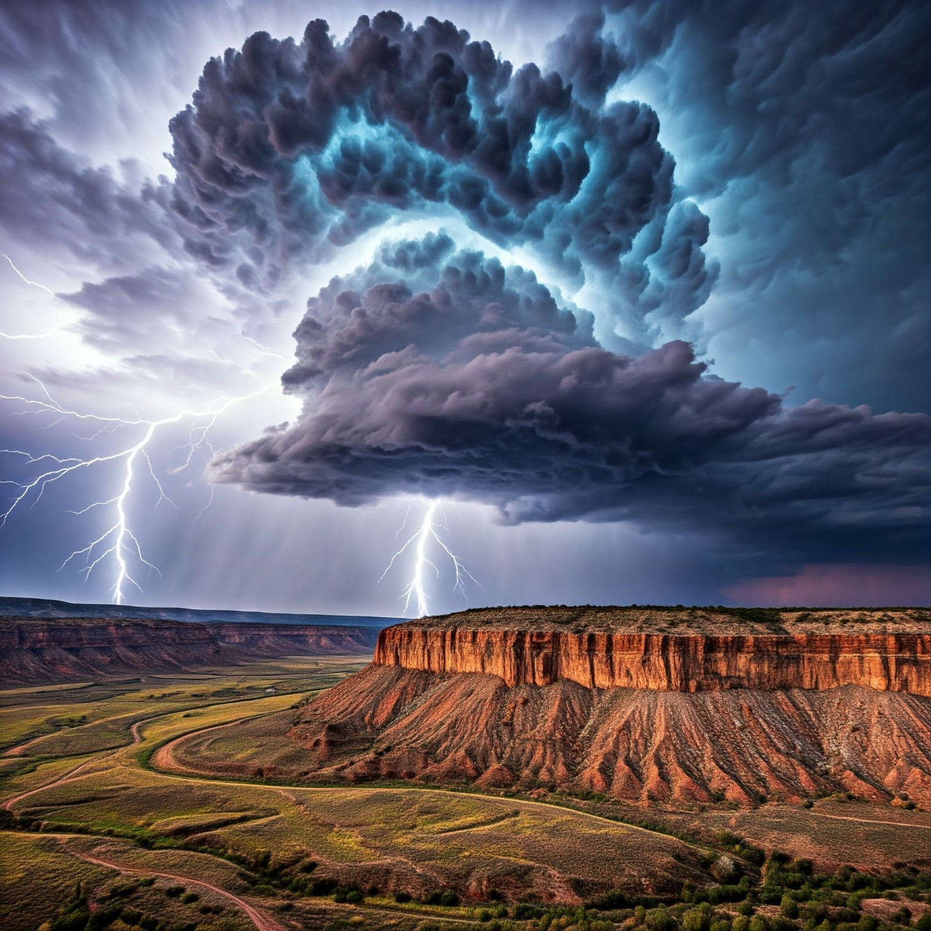
BIG THUNDERSTORM
Station 1(B) options (according to dice roll)
- You are struck by a large hail ball of ice! Call in pain 3 times. Roll again.
- You cannot see the stars! Fly 5 big circles calling! Roll again.
- The winds of the thunderstorm blow you quickly to Station 2. Flap, call, and celebrate all the way!
- The wind makes you work so much harder! Flap 5 times per step to station 2.
- The wind makes you go too high where it is painfully cold. Make your call in pain 10 times! Roll again.
- You lucked out and missed the storm! Fly happily to station 2 both calling and flapping 1 per step.
STATION 2 (B)

BACKYARD & CITY PARKS
Station 2(B) options (according to dice roll)
- You land in a city park of mowed grass. Fly in 5 big circles looking for food and calling.
- You land in a city park with native plants and abundant food. You eat and fly to Station 3.
- You land in a backyard with native plants. You eat and flap to station 3.
- Pesticides have been sprayed in the park sickening you. Fly back to Station1.
- You land in a backyard with a pet cat. You are pounced on! Scream your call! You got away! Roll again.
- You land in a backyard with abundant food and a cat watches you from inside a home. Flap to Station 3.

