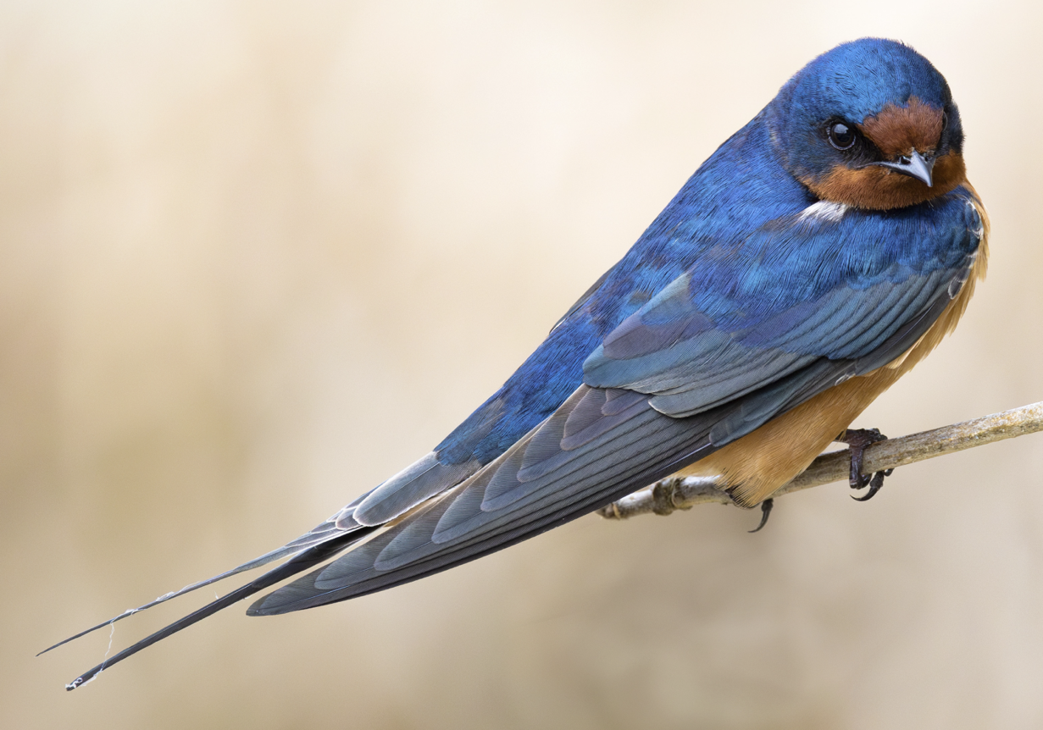
Name: Barn Swallow
Says: “vit veet”
Eats: flying insects
Did you know? Ones in WA and OR migrate to Columbia South America (over 4,000 miles), but ones from the eastern United States migrate all the way to Argentina (over 5,000 miles)!
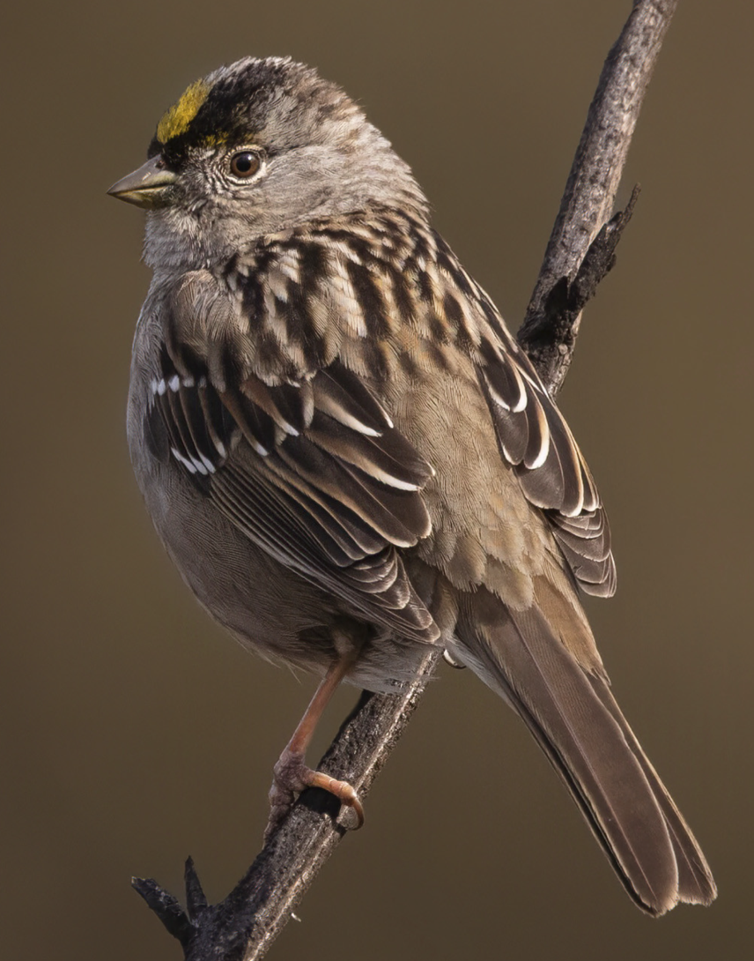
Name: Golden-crowned Sparrow
Says: “see sew so”
Eats: seeds, flower buds, insects
Did you know? They migrate from Alaska and the Yukon down to W Washington, W Oregon, and W California.
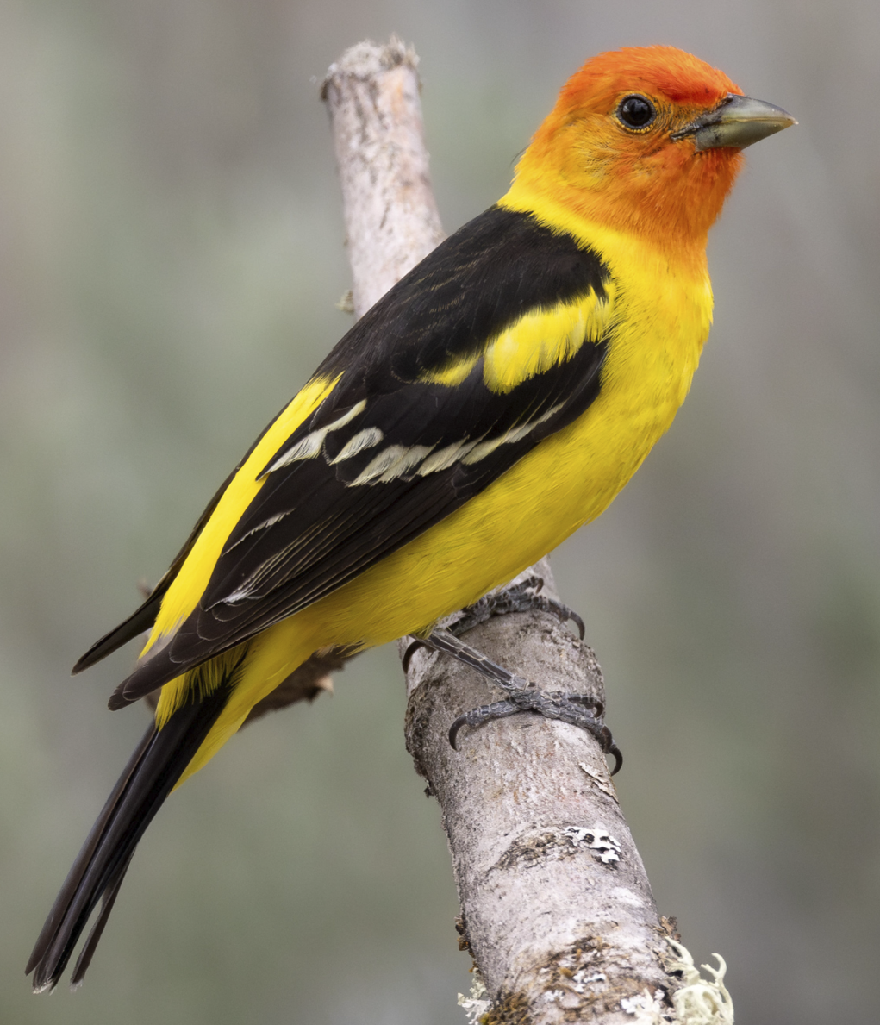
Name: Western Tanager
Says: “pitterit”
Eats: insects, dried fruit
Did you know? They migrate from NW forests down to the forests of western coasts of Central America
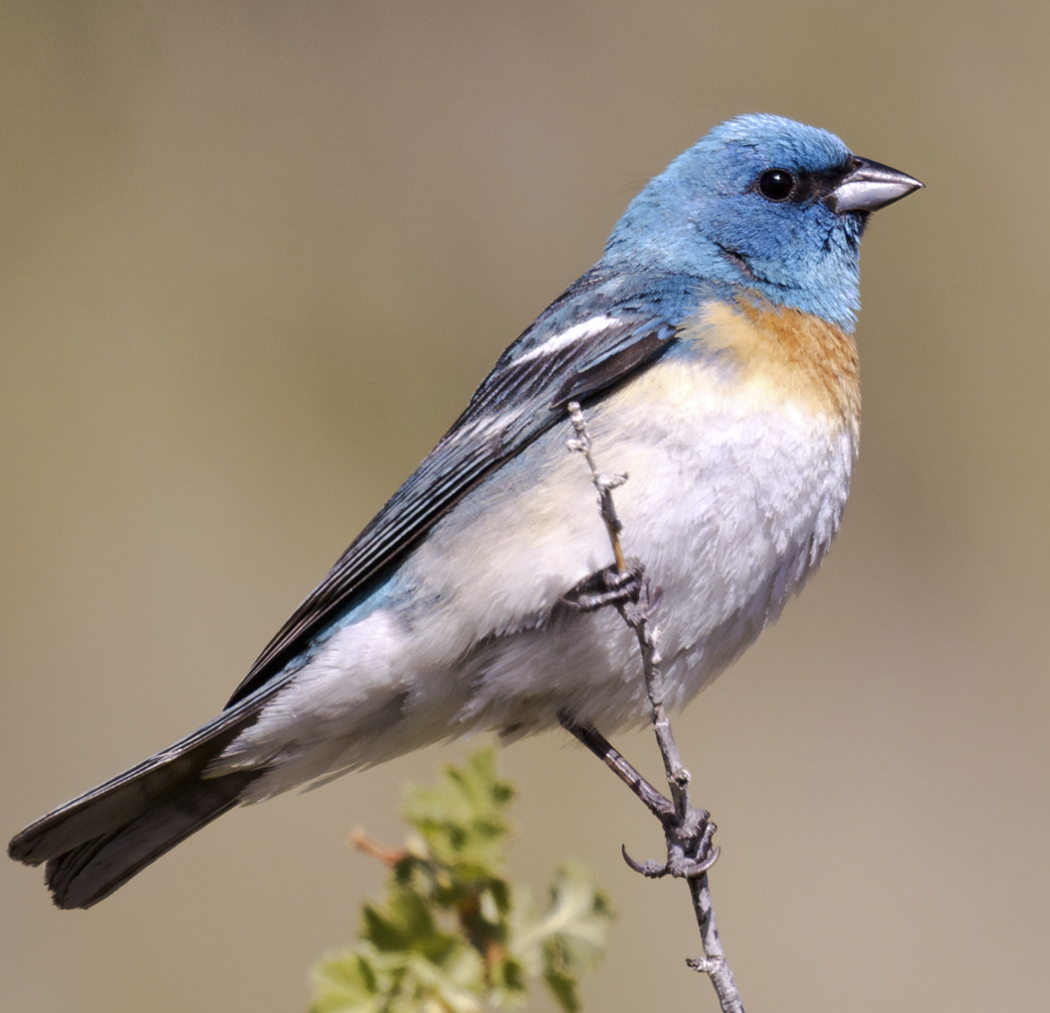
Name: Lazuli Bunting
Says: “pik, pik, pik, pik”
Eats: seeds, fruit, insects
Did you know? They migrate from the Pacific NW to Baja California and Mexico.

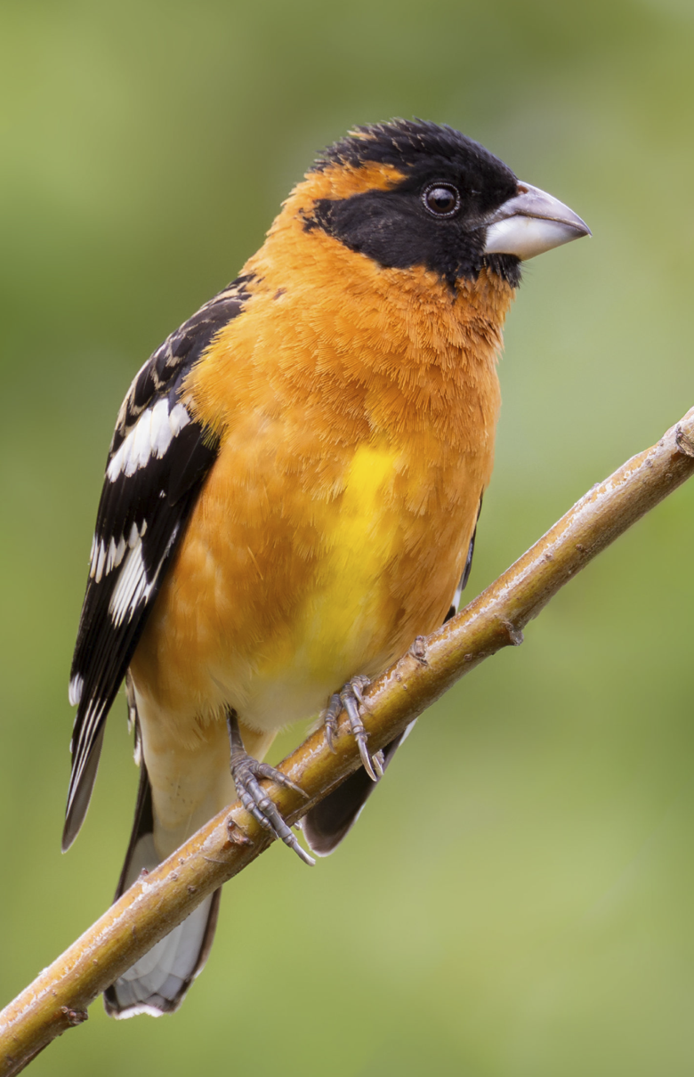
Name: Black-headed Grosbeak
Says: “PIK” ... “PIK”
Eats: insects, fruit, seeds
Did you know? They are a west coast bird who migrates to southern Mexico for the winter.
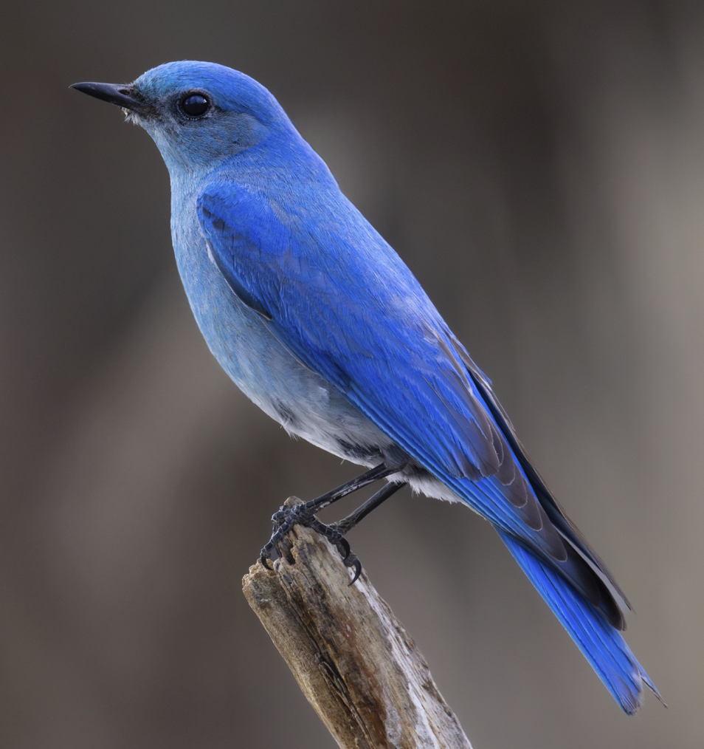
Name: Mountain Bluebird
Says: “jerff”
Eats: insects, spiders, seeds, fruit
Did you know? These birds migrate from mountains in the north half of North America to the south half in the winter. They love the mountains...thus the name.
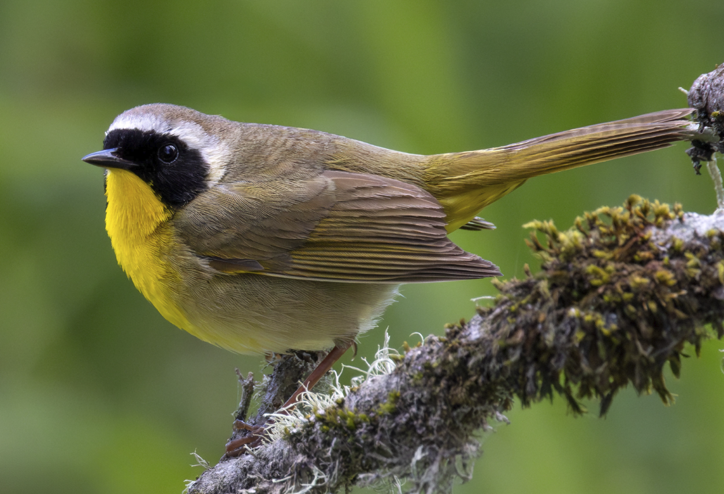
Name: Common Yellowthroat
Says: “wich-i-ty wich-i-ty wich-i-ty"
Eats: insects & spiders
Did you know? They migrate from the Yukon to the coasts of California, Mexico, and southern states.
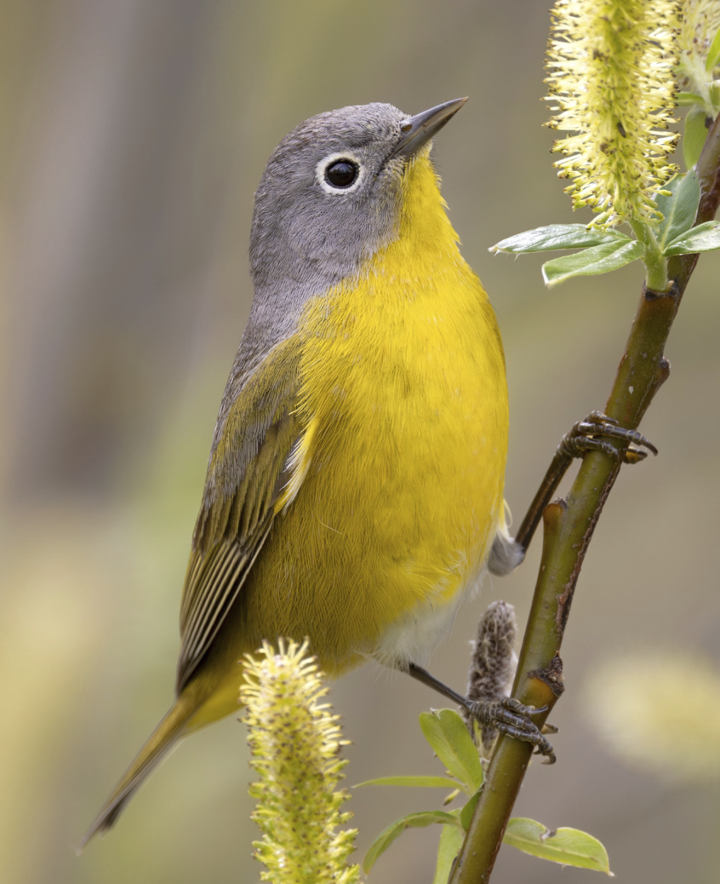
Name: Nashville Warbler
Says: “seeta seeta seeta pli pli pli”
Eats: insect adults & larvae
Did you know? In the west they live in our Cascade mountain forests and migrate to Mexico’s forests for winter.

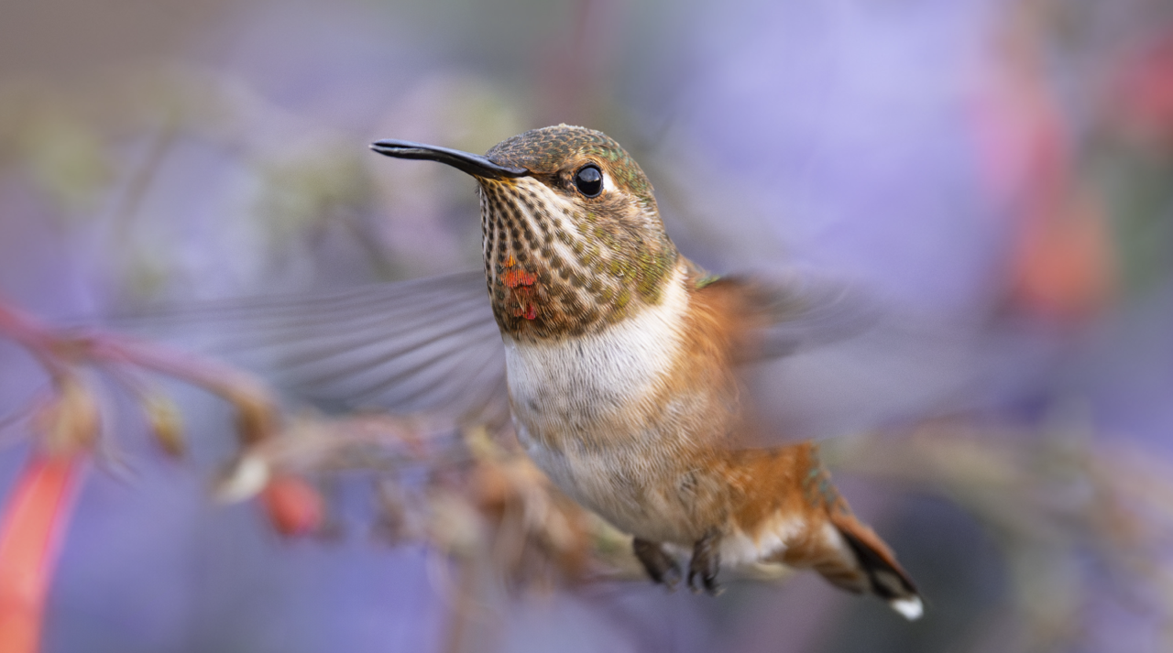
Name: Rufous Hummingbird
Says: “tzupity tzupity”
Eats: nectar from flowers & tiny insects
Did you know? They migrate up the west coast in the spring, but migrate south through the Rocky Mountains back to Mexico.

